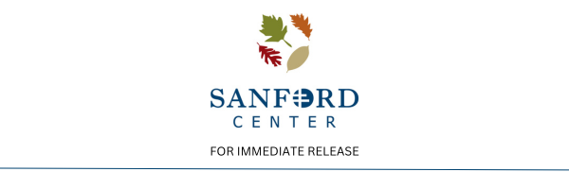

**NORTHERN MINNESOTA’S WOMEN’S EXPO TO RETURN MAY 10TH AT THE SANFORD CENTER**

(**BEMIDJI, MINN**– Mar. 7th, 2025) —The Sanford Center is excited to announce that the Northern Minnesota’s Women’s Expo is returning bigger and better than ever!

The Northern Minnesota’s Women’s Expo is set to return to The Sanford Center on May 10th during Women’s Health Month, with 80% of entrance proceeds going towards the Northern Minnesota Addiction Wellness Center. The entrance fee will be $5.

"We are so honored to be this year's chosen organization for the Women's Expo donation at the Sanford Event Center in Bemidji! This money will go to help create more resources for Substance Use Disorder and Mental Health in our community. This will help us create more resources that will be able to help and reach more clients than we are currently able to. We are working on getting additional services and resources established for people in our community to help with prevention and family support in addition to client services. Thank you to all our human services partner organizations working on helping our community be as healthy as possible,” stated Margot Kelsey, CEO, President, and LADC of the Northern Minnesota Addiction Wellness Center.

Not only is this expo supporting such an amazing organization, but this day will also provide women with an exceptional experience to pamper themselves and leave feeling empowered. With various vendors, demonstrations, a pop-up thrift store as well as influential speakers, there will surely be something here for everyone!

In previous years, this expo has featured great vendors and demonstrations, such as interactive art, photographers, jewelers, spas, travel, and more!

This expo will be an empowering day with many activities to participate in! The expo is currently seeking vendors, if you are interested, please reach out to Malaak Khattab, Event Manager, at The Sanford Center by emailing [mkhattab@thesanfordcenter.com](mailto:mkhattab@thesanfordcenter.com).

*Media Contact: Lexi Mudrick, Marketing Manager, lmudrick@thesanfordcenter.com*